My favourite animal
My favourite pet is a dog. I have got a york.
It is called Toffik. It has got black fur with brown patches. It is very small.
I like playing with him and I love him very much.

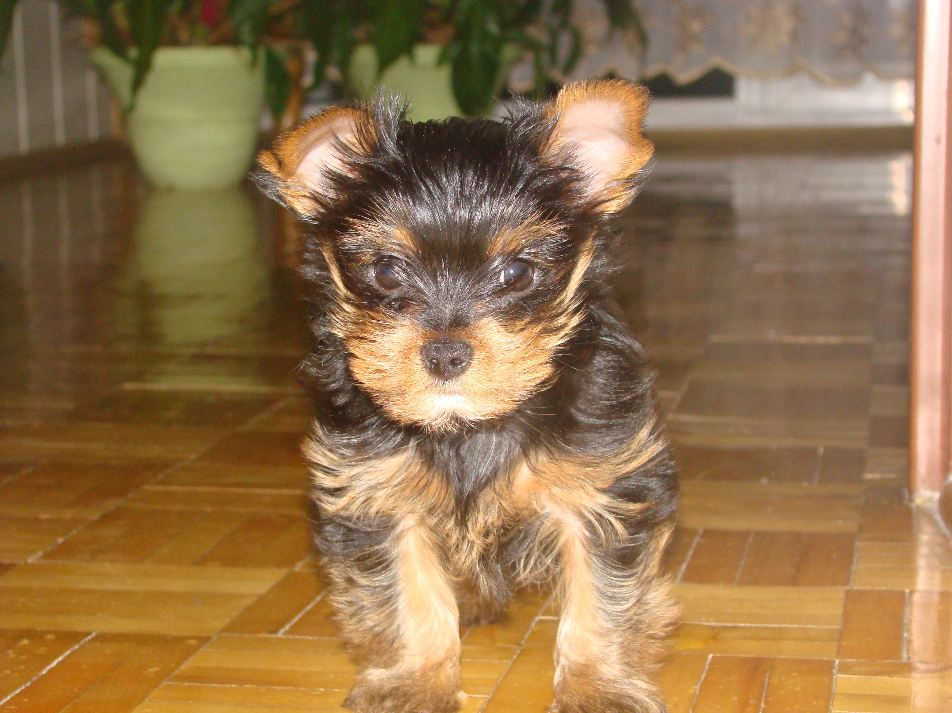

Author: Karolinka Pyka

